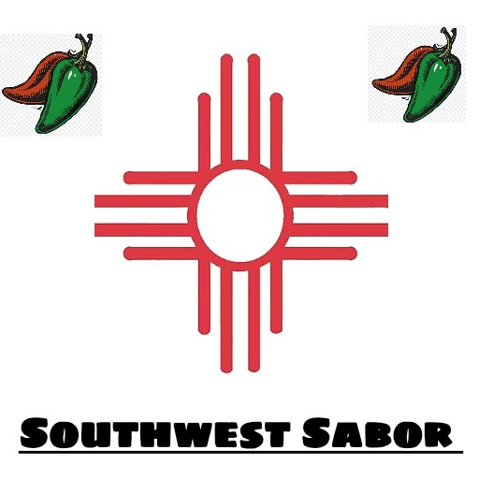
AUTHENTIC NEW MEXICAN CUISINE
505-514-1346
6250 Mcleod Dr. Ste.100
Las Vegas, NV. 89120

THURSDAY- SATURDAY 11am - 3pm (PICKUP, DOORDASH, GRUBHUB) MONDAY - TUESDAY 10am - 4pm (CALL IN ORDERS WITH DELIVERY)
Our Company, Southwest Sabor, originated in New Mexico. The name Southwest reflects our goal of featuring not only New Mexico’s cuisine but also the signature dishes of other Southwest states.
Southwest Sabor (Facebook)
Southwestsabor2020 (Instagram)
ENCHILADAS (FAMILY STYLE)
ONE DOZEN ROLLED CHEESE ENCHILADAS WITH YOUR CHOICE OF CHILE (RED, GREEN OR CHRISTMAS) $23.00
WITH BEEF OR CHICKEN $28.00
ENCHILADA DINNERS $14.00
THREE CHEESE ENCHILADAS, CHOICE OF CHILE, (CHOICE OF RED, GREEN OR CHRISTMAS) BEANS AND RICE
WITH BEEF OR CHICKEN $16.00

BREAKFAST
(SERVED ANYTIME OF DAY)

Burritos choice of Sausage, Bacon, or Beans and includes Egg, Potato & Cheese $8.00
Add red or green $1.00 Handheld
Add red or green $2.00 Smothered

Tex-mex Burrito includes beans, eggs, tomatoes, onions, jalapenos and cheese. $9.00 Add Bacon or Sausage $1.00

Huevos Rancheros Breakfast-includes fried corn tortilla, 2 eggs,( Red, Green or Christmas), cheese, refried beans & potatoes, your choice of bacon or sausage $13.00

El Mexicana Breakfast- includes 2 scrambled eggs with cheese sauce, topped with pico de gallo, refried beans and your choice of sausage or bacon. $13.00

BURRITOS

Bean and cheese- refried beans, cheese and tortilla
$4.00

Taco Meat-with beans, cheese, Red or Green Chile (Handheld)
$8.00
Smothered in Red or Green Chile $10.00

Chicken- with beans, cheese, Red or Green Chile (Handheld)
$8.00
Smothered in Red or Green Chile $10.00

Carnitas- with beans, cheese, Red or Green Chile (Handheld)
$8.00
Smothered in Red or Green Chile $10.00

Steak- with beans, cheese, Red or Green Chile (Handheld)
$10.00
Smothered in Red or Green Chile $12.00

Carne Adovada- with beans, rice and cheese (Handheld) $10.00
Smothered in Red or Green Chile $12.00

BURGERS (Fresh not Frozen)

Traditional 1/3 lb Burger $7.00
Mayo or Mustard, Lettuce, Tomato, Pickles, and Onion
Add Cheese $1.00, Add Bacon $1.00
Add Green Chile $1.00

1/3lb Bacon Cheese Burger- $9.00
Mayo or Mustard, Lettuce, Tomato, Onion, Pickles, Cheddar cheese and Bacon Add Green Chile $1.00

1/3lb 505 Burger $9.00
Mayo, Lettuce, Tomato, Onion, Pickles, Green Chile, & Cheddar Cheese
Add Bacon $1.00

1/3lb Texas Burger- $9.00
Mustard, Texas Chili, Pickles, Cheddar cheese

1/3lb Quemado Burger $9.00
Spicy Mayo, Lettuce, Tomato, Onions, Jalapenos, Green Chile, and pepperjack cheese

1/3lb Alien Tortilla Burger $10.00
Flour tortilla, Green Chile, Cheese and 1/3lb patty
Smothered in Green Chile, garnished with Lettuce & Tomato

1/3LB Rodeo Burger $10.00
BBQ sauce, bacon, cheddar cheese, grilled jalapenos, sauteed onions and pickles

1/3 lb Guacamole Bacon Jalapeno Burger $10.00
Guacamole, Bacon, Grilled Jalapeno slices, Pepper Jack cheese, Mayo, lettuce, Tomato, onion and pickles.

Add chips or fries and soda to any burger for $3.00
All burgers will be cooked to correct internal temperature.

EXTRAS

Nachos $6.00
Chips w/ Nacho Cheese and Jalapenos upon request
Southwest Nachos- $9
Chips, Refried Beans, Taco Meat, Lettuce, Tomato, Jalapenos, & Nacho Cheese
Texas Nachos-$9
Chips, Nacho Cheese, Texas Chili, Lettuce and Tomato
NM. Frito Pie-$9
Chips, Red Chile, Whole Beans, Taco Meat, Shredded-Cheese, Lettuce, Tomato & Onion
Quesadilla $5.00
Toasted Tortilla, Cheese, and salsa
Tostada $5.00- Tostada shell, refried beans, cheese, lettuce, tomatoes, and salsa
Albuquerque Turkey $7.00- Toasted sourdough bread, pepperjack cheese, turkey, mayonnaise, & green chile strip
Taco Salad $10.00- Fried tortilla bowl, beans, rice lettuce, taco meat, cheese, tomatoes, and salsa
Taquitos $7.00- 5 fried taquitos, salsa, sour cream, and guacamole

Add Taco meat, Chicken or Carnitas $3.00 Steak $4.00

FRIES
French Fries$4.00
Nacho Fries $7.00- Nacho cheese and Jalapenos
NM. Green Chile Cheese Fries$8.00- Green Chile and cheddar cheese
Texas Chile Fries $7.00- Texas Chile and cheddar cheese

Add Taco meat, Chicken or Carnitas $3.00 Steak $4.00

- CHIPS AND SALSA $5.00
- CHIPS AND PICO DE GALLO $5.00
- REFRIED OR WHOLE BEANS pint $4.00 quart $8.00
- SPANISH RICE pint $4.00 quart $8.00
- CARNE ADOVADA pint $7.00 quart $14.00
- GREEN CHILE STEW pint $7.00 quart $14.00
- SOPAPILLAS $5.00 per order
- CHIPS $1.00
- SHASTA SODA $2.00

DINNERS

BEEF TACO PLATE $13.00- 3 Beef tacos, lettuce, tomatoes, cheese, refried beans, and rice

CARNITA TACO PLATE $13.00- 3 Carnita tacos, cilantro, onion, refried beans, and rice

CHICKEN TACO PLATE $13.00- 3 Chicken tacos, cilantro, onion, refried beans, and rice

STEAK TACO PLATE $15.00- 3 Steak tacos, cilantro, onion, refried beans, and rice

CARNE ADOVADA PLATE $15.00- Carne adovada, rice, beans and tortillas

SOUTHWEST COMBINATION PLATE $15.00- Cheese enchilada, beef taco, chile relleno, rice, beans and salsa

FAJITA PLATE $16.00- Steak or chicken, (sautéed bell peppers, poblano peppers and onion mix) refried beans, rice and tortillas (sour cream, salsa and guacamole)

